Project Design Phase-II
Technology Stack (Architecture & Stack)

Date | 30 September 2026
Team ID | SWTID-2026-8376
Project Name | AI Weather Wise API
Maximum Marks | 4 Marks

Technical Architecture:
This diagram shows the logical WeatherWise API components. Technology, provider, storage, and deployment choices remain TBD.
AI WeatherWise API Logical Architecture
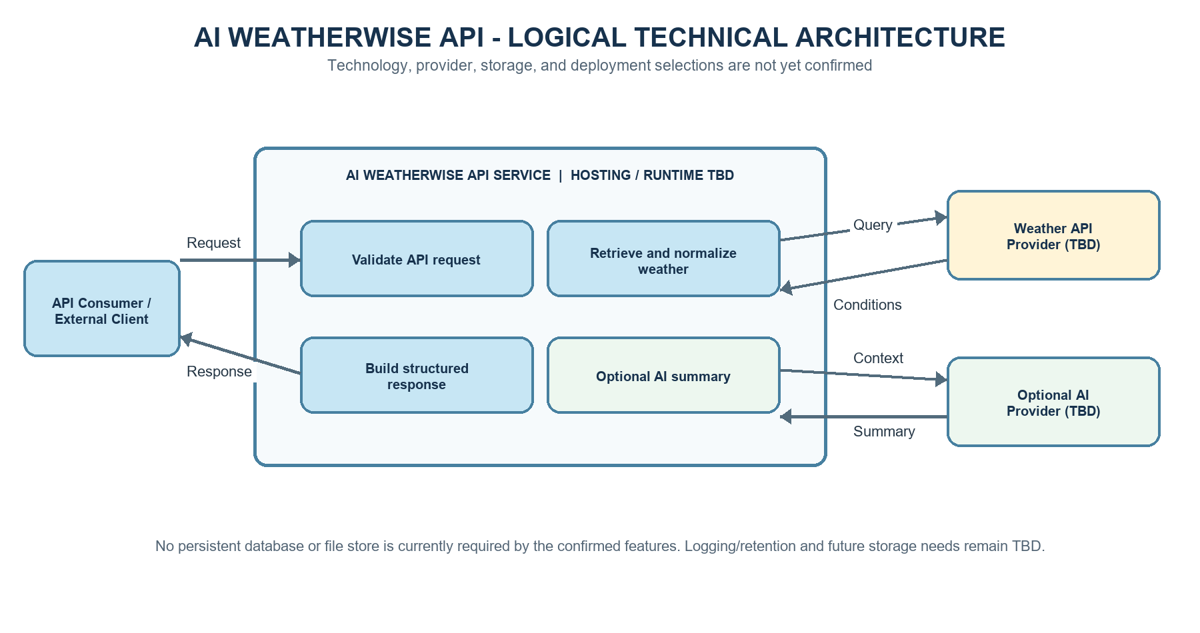
Table-1 : Components & Technologies:
S.No | Component | Description | Technology
1. | API Consumer / Client | Consumes API requests and responses. A WeatherWise-owned user interface is not in the confirmed scope. | Client application technology TBD / external
2. | Application Logic - Request Handling | Validate city or coordinate input and route requests to the weather lookup process. | Language and framework TBD
3. | Application Logic - Weather Processing | Retrieve current conditions and normalize them into the documented response schema. | Backend runtime and provider integration TBD
4. | Application Logic - Optional Summary | Create a plain-language summary only when requested; a summary failure must not block core weather data. | AI service/model and integration TBD
5. | Database | No persistent application data requirement is confirmed for the current features. Reassess if retention or account features are added. | None currently selected
6. | Cloud Database | No cloud database requirement is confirmed. | Not currently required; reassess if scope changes
7. | File Storage | No user file uploads or generated files are currently required. Operational log retention policy is TBD. | No file storage selected
8. | External API - Weather | Provide current weather conditions for a city or coordinate request. | Weather data provider/API TBD
9. | External API - AI Summary | Optionally convert returned weather conditions into a concise plain-language summary. | AI summary provider/API TBD
10. | Machine Learning Model | Optional natural-language summary generation; no model has been selected or deployed. | Model or hosted service TBD
11. | Infrastructure (Server / Cloud) | Host the API and support secure connections to external providers. | Deployment target, runtime, and server configuration TBD

Table-2: Application Characteristics:
S.No | Characteristics | Description | Technology
1. | Open-Source Frameworks | Choose frameworks after confirming the implementation language and project constraints; no framework is selected yet. | Framework/library selection TBD
2. | Security Implementations | Validate inputs, protect provider credentials, encrypt network traffic, and avoid sensitive details in errors. Authentication and access-control policies require team confirmation. | TLS, secrets handling, authentication, IAM, and firewall choices TBD
3. | Scalable Architecture | Keep the logical request flow clear; choose service boundaries and scaling approach after expected traffic is known. No microservice design is confirmed. | Hosting and scaling approach TBD; load target TBD
4. | Availability | Handle provider timeouts and failures predictably. Define monitoring, recovery expectations, and the uptime target before release. | Monitoring/recovery tools and uptime target TBD
5. | Performance | Measure weather-provider and optional summary response times under expected traffic. Agree latency, throughput, caching, and rate-limit targets before implementation. | Performance targets and optimization technology TBD

References:
https://c4model.com/
https://www.ibm.com/cloud/architecture
https://aws.amazon.com/architecture
https://medium.com/the-internal-startup/how-to-draw-useful-technical-architecture-diagrams-2d20c9fda90d

